**WEB PROGRAMMING MINI PROJECT**

***NAME-TAMANNA***

***REGISTRATION NUMBER-23BCE0068***

# • INDEX.html

|  |
| --- |
| <!--  Student Name: Tamanna  Register number: 23BCE0068  File Name: about.html Date: March 31, 2025  -->  <!DOCTYPE html>  <html lng="en">  <head>  <!-- Meta information and external resource links -->  <title>Complete Fitness - Free Trial | Forward Fitness Club</title>  <meta charset="utf-8">  <meta name="viewport" content="width=device-width, initial-scale=1">  <link rel="stylesheet" href="css/styles.css">  <meta name="description" content="The Forward Fitness Club is an elite fitness center dedicated to helping clients achieve their fitness and nutrition goals."> <!-- External fonts and favicon configurations -->  <link href="https://fonts.googleapis.com/css2?family=Francois+One&family=Roboto+Slab&display=swap" rel="stylesheet">  <link rel="shortcut icon" href="images/favicon.ico">  <link rel="icon" type="images/png" sizes="32x32" href="images/favicon-32.png">  <link rel="apple-touch-icon" sizes="180x180" href="images/apple-touch-icon.png">  <link rel="icon" sizes="192x192" href="images/android-chrome-192.png">  </head>  <body>  <!-- Main container for all content -->  <div id="container">  <!-- Mobile Navigation Menu -->  <nav class="mobile-nav">  <div id="menu-links">  <a href="index.html">Home</a>  <a href="about.html">About Us</a>  <a href="classes.html">Classes</a>  <a href="nutrition.html">Nutrition</a> |

|  |
| --- |
| <a href="contact.html">Contact Us</a>  </div>  <a class="menu-icon" onclick="hamburger()">  <div>&#9776;</div>  </a>  </nav>  <!-- Header with logo -->  <header id="ffc-logo">  <a href="index.html"><img src="images/forward-fitness-logo.jpeg" alt="Forward Fitness Club logo"></a> </header>    <!-- Tablet and Desktop Navigation -->  <nav class="tablet-desktop">  <ul>  <li><a href="index.html">Home</a></li>  <li><a href="about.html">About Us</a></li>  <li><a href="classes.html">Classes</a></li>  <li><a href="nutrition.html">Nutrition</a></li>  <li><a href="contact.html">Contact Us</a></li>  </ul>  </nav>  <!-- Hero Image Section -->  <div id="hero" class="tablet-desktop">  <img src="images/hero-image.jpg" alt="left arm extended holding a weight"> </div>    <!-- Main Content Area -->  <main>  <!-- Mobile View Content -->  <div class="mobile">  <p>Welcome to Forward Fitness Club. Our mission is to help our clients meet their fitness and nutrition goals. </p>  <h3>FREE One-Week Trial Membership!</h3>  <p>Call Us Today to Get Started</p>  <p class="tel-link"><a href="tel:8145559608">+91 7503000787</a></p>  <h4>Fitness Club Hours:</h4>  <ul class="hours">  <li>Mon-Thu: 6:00am-6:00pm</li>  <li>Friday: 6:00am-4:00pm</li>  <li>Saturday: 8:00am-6:00pm</li>  <li>Sunday: Closed</li>  </ul>  </div>  <!-- Tablet and Desktop View Content -->  <div class="tablet-desktop">  <p>Welcome to Forward Fitness Club. Our mission is to help our clients meet their fitness and nutrition goals.</p> <p>If you have struggled with getting healthy and need the motivation and resources to make a healthy lifestyle change, contact us today. Our facility includes state-of-the-art equipment, convenient group training classes, and nutrition tips and information to keep you healthy.</p>  <p>We provide a FREE one-week membership so you can experience the benefits of our equipment and facility. This one-week trial gives you complete access to our equipment, training classes, and nutrition planning. Contact us today to <span class="action">start your free trial!</span></p>  </div>  <!-- Image Grid Section -->  <div class="grid"> |

|  |
| --- |
| <figure class="frame">  <a href="classes.html"><img src="images/fitness-group.jpg" alt="group of fitness people"></a>  <figcaption class="pic-text">Group Fitness</figcaption> </figure> |

<figure class="frame">

<a href="nutrition.html"><img src="images/food-heart.jpg" alt="healthy food in the shape of a heart"></a>

<figcaption class="pic-text">Meal Plans</figcaption>

</figure>

<figure class="frame">

<a href="contact.html"><img src="images/personal-trainer.jpg" alt="personal trainer with a clipboard"></a>

<figcaption class="pic-text">Start Today</figcaption>

</figure>

</div>

</main>

<!-- Footer Section -->

<footer>

<div class="copyright">

<p>&copy; Copyright 2025. All Rights Reserved.</p>

<p><a href="mailto:mangalfir@gmail.com">mangalfit@gmail.com</a></p> </div> <div class="social">

<a href="https://www.facebook.com" target="_blank"><img src="images/facebook-logo.png" alt="black and white Facebook logo"></a>

<a href="https://twitter.com" target="_blank"><img src="images/twitter-logo.png" alt="black and white Twitter logo"></a> </div>

</footer>

</div>

<script src="scripts/script.js"></script>

</body>

</html>

# • Nutrition.html-

|  |
| --- |
| <!--  Student Name: Tamanna  Register number: 23BCE0068    File Name: about.html  Date: March 31, 2025 -->  <!DOCTYPE html>  <html lang="en">  <head>  <title>Nutrition Guidance | Forward Fitness Club</title>  <meta charset="utf-8">  <meta name="viewport" content="width=device-width, initial-scale=1">  <link rel="stylesheet" href="css/styles.css">  <meta name="description" content="Forward Fitness Club provides nutrition guides and meal planning to help you meet your nutrition goals.">  <link href="https://fonts.googleapis.com/css2?family=Francois+One&family=Roboto+Slab&display=swap" rel="stylesheet">  <link rel="shortcut icon" href="images/favicon.ico">  <link rel="icon" type="images/png" sizes="32x32" href="images/favicon-32.png">  <link rel="apple-touch-icon" sizes="180x180" href="images/apple-touch-icon.png">  <link rel="icon" sizes="192x192" href="images/android-chrome-192.png"> </head> <body> |

<div id="container">

<!-- Mobile Nav -->

<nav class="mobile-nav">

<div id="menu-links">

<a href="index.html">Home</a>

<a href="about.html">About Us</a>

<a href="classes.html">Classes</a>

<a href="nutrition.html">Nutrition</a>

<a href="contact.html">Contact Us</a>

</div>

<a class="menu-icon" onclick="hamburger()">

<div>&#9776;</div>

</a>

</nav>

<!-- Use the header area for the website name or logo -->

<header id="ffc-logo">

<a href="index.html"><img src="images/forward-fitness-logo.jpeg" alt="Forward Fitness Club logo"></a> </header>

<!-- Tablet, Desktop Nav -->

<nav class="tablet-desktop">

<ul>

<li><a href="index.html">Home</a></li>

<li><a href="about.html">About Us</a></li>

<li><a href="classes.html">Classes</a></li>

<li><a href="nutrition.html">Nutrition</a></li>

<li><a href="contact.html">Contact Us</a></li>

</ul>

</nav>

<!-- Nutrition Hero Image -->

<div id="hero">

<img src="images/hero-veggies.jpg" alt="fresh vegetables">

</div>

<!-- Use the main area to add the main content of the webpage -->

<main class="grid">

<article>

<h3>Food for Thought</h3>

<img src="images/food-thought.jpg" alt="food for thought image" class="round">

<p>Good nutrition is a lifestyle, not a diet. It starts with a new way of thinking about food. Think of your body as a vehicle that uses food for fuel. Fill your tank with the right type of fuel.</p>

<p>Do not approach your nutrition plan as a diet plan, but rather, a lifestyle change. If you make a permanent change, you will see big results. The key to success is a daily focus on your goal.</p>

<p>Portion your meals and track your calories. There are many free mobile apps available to help track your activity level and calories.</p>

<p>Control impulsive urges to buy junk food, and instead, allow yourself to one "cheat" meal a week.</p> </article>

<article>

<h3>What to Eat</h3>

<img src="images/fresh-food.jpg" alt="fresh vegetables, fruit, eggs, and nuts" class="round">

<p>Use the following as a guideline:</p>

<ul>

<li>Protein, such as eggs, chicken, and lean red meat</li>

<li>Vegetables, but avoid corn and peas</li>

<li>Fruit</li>

<li>Fat, such as olive oil, nuts, and seeds</li> </ul>

|  |
| --- |
| <p>Limit the consumption of bread, pasta, white potatoes, and processed food. These foods are high in carbohydrates.</p>  <p>When you shop for groceries, shop the outside aisles and buy organic when possible. Stock up on fresh vegetables, almond flour, and flax seed.</p>  <p>Check out our Meal of the Week for new meal ideas.</p>  </article>  <article>  <h3>Meal of the Week</h3>  <img src="images/food-chicken.jpg" alt="herb roasted chicken" class="round">  <h4>Herb Roasted Chicken</h4>  <h4>Ingredients:</h4>  <ul>  <li>boneless, skinless chicken breast (organic preferred)</li>  <li>1 tsp Herbes de Provence</li>  <li>1 tsp lemon juice</li>  <li>1 tsp olive oil</li>  <li>1 tsp sea salt</li>  <li>&frac14; tsp pepper</li>  </ul>  <h4>Instructions:</h4>  <p>Combine all ingredients in a plastic bag and marinate for at least an hour. Preheat oven to 350 degrees. Bake chicken for 30-35 minutes or until juices run clear. Broil on high for two minutes or until brown. Serve with a fresh side salad.</p>  </article>  <aside class="tablet-desktop grid-item4">  <p>Did you know the average Indian consumes 3 lbs of sugar each week?</p>  <p>Did you know that avocados are a good source of Vitamin B?</p>  <p>Did you know the average active adult should consume about 2,0000 calories a day?</p> </aside> </main>  <!-- Use the footer area to add webpage footer content -->  <footer>  <div class="copyright">  <p>&copy; Copyright 2025. All Rights Reserved.</p>  <p><a href="mailto:mangalfir@gmail.com">mangalfit@gmail.com</a></p> </div>  <div class="social">  <a href="https://www.facebook.com" target="_blank"><img src="images/facebook-logo.png" alt="black and white Facebook logo"></a>  <a href="https://twitter.com" target="_blank"><img src="images/twitter-logo.png" alt="black and white Twitter logo"></a> </div>  </footer>  </div>  <script src="scripts/script.js"></script>  </body>  </html> |

# • Contact.html

<!--

Student Name: Tamanna Register number: 23BCE0068

File Name: about.html

|  |
| --- |
| Date: March 31, 2025  -->  <!DOCTYPE html>  <html lang="en">  <head>  <title>Contact Us - Locaion | Forward Fitness Club</title>  <meta charset="utf-8">  <meta name="viewport" content="width=device-width, initial-scale=1">  <link rel="stylesheet" href="css/styles.css">  <meta name="description" content="Forward Fitness Club provides a complimentary one-week trial membership.  Contact us today to learn more.">  <link href="https://fonts.googleapis.com/css2?family=Francois+One&family=Roboto+Slab&display=swap" rel="stylesheet">  <link rel="shortcut icon" href="images/favicon.ico">  <link rel="icon" type="images/png" sizes="32x32" href="images/favicon-32.png">  <link rel="apple-touch-icon" sizes="180x180" href="images/apple-touch-icon.png">  <link rel="icon" sizes="192x192" href="images/android-chrome-192.png"> </head> <body>    <div id="container">  <!-- Mobile Nav -->  <nav class="mobile-nav">  <div id="menu-links">  <a href="index.html">Home</a>  <a href="about.html">About Us</a>  <a href="classes.html">Classes</a>  <a href="nutrition.html">Nutrition</a>  <a href="contact.html">Contact Us</a>  </div>  <a class="menu-icon" onclick="hamburger()">  <div>&#9776;</div>  </a>  </nav>    <!-- Use the header area for the website name or logo -->  <header id="ffc-logo">  <a href="index.html"><img src="images/forward-fitness-logo.jpeg" alt="Forward Fitness Club logo"></a> </header>    <!-- Tablet, Desktop Nav -->  <nav class="tablet-desktop">  <ul>  <li><a href="index.html">Home</a></li>  <li><a href="about.html">About Us</a></li>  <li><a href="classes.html">Classes</a></li>  <li><a href="nutrition.html">Nutrition</a></li>  <li><a href="contact.html">Contact Us</a></li>  </ul>  </nav>  <!-- Use the main area to add the main content of the webpage -->  <main>  <div id="contact"> |

|  |
| --- |
| <h2>Ready to get started? Contact us today.</h2>  <h4 class="mobile tel-link"><a href="tel:8145559608">+91 7503000787</a></h4>  <h4 class="tablet-desktop tel-num">+91 7503000787</h4> |

<h4>Email us: <a href="mailto:forwardfitness@club.net" class="contact-emaillink">mangalfit@gmail.com</a></h4>

<h3 class="offer" onclick="discount()" id="special">View Promo Code</h3>

<h4>2nd street ,VIT VELLORE, 632014</h4>

<iframe

src="https://www.google.com/maps/embed?pb=!1m18!1m12!1m3!1d3888.5551557257007!2d79.1533587148228 3!3d12.969228490855713!2m3!1f0!2f0!3f0!3m2!1i1024!2i768!4f13.1!3m3!1m2!1s0x3bad479f0ccbe067%3A0xfef2 22e5f36ecdeb!2sVellore%20Institute%20of%20Technology!5e0!3m2!1sen!2sin!4v1679900000000!5m2!1sen!2sin" width="600" height="450" style="border:0;" allowfullscreen="" loading="lazy" referrerpolicy="no-referrerwhendowngrade" class="map"></iframe>

</div>

<div id="form">

<h2>Complete the form below to begin your free trail.</h2>

<form class="form-grid"> <!-- Start Form -->

<fieldset>

<legend>Customer Information</legend>

<label for="fName">First Name:</label>

<input type="text" name="fName" id="fName" required> <label for="fName">Last Name:</label>

<input type="text" name="fName" id="lName" required>

<label for="email">Email:</label>

<input type="email" name="email" id="email" required>

<label for="phone">Phone:</label>

<input type="tel" id="phone" name="phone" required>

</fieldset>

<fieldset>

<legend>Additional Information</legend>

<p>I would like more information about:</p>

<label for="grpfit"><input type="checkbox" name="interest" id="grpfit" value="Group Fitness">Group

Fitness</label>

<label for="prtrain"><input type="checkbox" name="interest" id="prtrain" value="Personal Training">Personal Training</label>

<label for="nutr"><input type="checkbox" name="interest" id="nutr" value="Nutrition">Nutrition</label>

</fieldset>

<fieldset>

<legend>Referral Source</legend>

<label for="reference">How did you find us?</label>

<select name="reference" id="reference">

<option value="ad">Advertisement</option>

<option value="friend">Friend</option>

<option value="google">Google</option>

<option value="social">Social Media</option>

<option value="other">Other</option>

</select>

<label for="questions">Questions?</label>

<textarea id="questions" name="questions" rows="5" cols="35"></textarea>

<label for="promo">Promo Code:</label>

<input type="text" id="promo" name="promo">

</fieldset>

<input type="submit" id="submit" value="Submit" class="btn">

</main>

<!-- Use the footer area to add webpage footer content -->

<footer>

<div class="copyright">

<p>&copy; Copyright 2025. All Rights Reserved.</p>

|  |
| --- |
| <p><a href="mailto:mangalfir@gmail.com">mangalfit@gmail.com</a></p> </div>  <div class="social"> |

<a href="https://w ww.facebook.com

"

target="_blank"> <img src="images/face book-logo.png" alt="black and white Facebook logo"></a> <a href="https://twi tter.com" target="_blank"> <img src="images/twit ter-logo.png" alt="black and white Twitter logo"></a>

</div>

</footer>

</div>

<script src="scripts/scri pt.js"></script> </body> </html>

# • Classes.html

|  |
| --- |
| <!--  Student Name: Tamanna  Register number: 23CE0068  Date: March 31, 2025  -->  <!DOCTYPE html>  <html lang="en">  <head>  <title>Fitness Class Schedule | Forward Fitness Club</title>  <meta charset="utf-8">  <meta name="viewport" content="width=device-width, initial-scale=1">  <link rel="stylesheet" href="css/styles.css">  <meta name="description" content="Forward Fitness Club has many fitness classes to meet your needs, including boot camp, cardio, kickboxing, spinning, yoga, and Zumba.">  <link href="https://fonts.googleapis.com/css2?family=Francois+One&family=Roboto+Slab&display=swap" rel="stylesheet">  <link rel="shortcut icon" href="images/favicon.ico">  <link rel="icon" type="images/png" sizes="32x32" href="images/favicon-32.png">  <link rel="apple-touch-icon" sizes="180x180" href="images/apple-touch-icon.png">  <link rel="icon" sizes="192x192" href="images/android-chrome-192.png"> </head> <body>    <div id="container">  <!-- Mobile Nav -->  <nav class="mobile-nav">  <div id="menu-links">  <a href="index.html">Home</a>  <a href="about.html">About Us</a>  <a href="classes.html">Classes</a>  <a href="nutrition.html">Nutrition</a>  <a href="contact.html">Contact Us</a>  </div>  <a class="menu-icon" onclick="hamburger()">  <div>&#9776;</div>  </a>  </nav>    <!-- Use the header area for the website name or logo --> <header id="ffc-logo"> |

|  |
| --- |
| <a href="index.html"><img src="images/forward-fitness-logo.jpeg" alt="Forward Fitness Club logo"></a> </header>    <!-- Tablet, Desktop Nav -->  <nav class="tablet-desktop">  <ul>  <li><a href="index.html">Home</a></li>  <li><a href="about.html">About Us</a></li>  <li><a href="classes.html">Classes</a></li>  <li><a href="nutrition.html">Nutrition</a></li>  <li><a href="contact.html">Contact Us</a></li>  </ul>  </nav>  <!-- Classes Hero Image -->  <div id="hero" class="tablet-desktop">  <img src="images/classes-hero-image.jpg" alt="group of fitness people"> </div>  <!-- Use the main area to add the main content of the webpage -->  <main>  <div class="mobile">  <h3>Group Fitness Classes</h3>  <p>Boot Camp: TR 5am &amp; 5pm</p>  <p>Cardio: MWF 6am &amp; 5pm</p>  <p>Kickboxing: MWF 8am &amp; 7:15pm</p>  <p>Spinning: TR 6am &amp; 6pm</p>  <p>Yoga: TR 6am &amp; 6pm</p>  <p>Zumba: MWF 7am &amp; 6pm</p>  </div>  <div class="tablet-desktop">  <table> <!-- Start Table -->  <caption>Group Fitness Class Schedule</caption>  <tr><!-- Row 1 -->  <th>Class</th>  <th>Days</th>  <th>Times</th>  <th>Instructor</th>  <th>Room</th>  </tr>  <tr><!-- Row 2 -->  <td>Cardio</td>  <td>Mon, Wed, Fri</td>  <td>6:00am, 6:00pm</td>  <td>Schultz</td>  <td>B</td>  </tr>  <tr><!-- Row 3 -->  <td>Boot Camp</td>  <td>Tue, Thu</td>  <td>5:00am, 5:00pm</td>  <td>Taylor</td>  <td>B</td>  </tr>  <tr><!-- Row 4 -->  <td>Spinning</td> |

|  |
| --- |
| <td>Tue, Thu</td>  <td>6:00am, 6:00pm</td>  <td>Roberts</td>  <td>A</td> |

</tr>

<tr><!-- Row 5 -->

<td>Kickboxing</td>

<td>Mon, Wed, Fri</td>

<td>8:00am, 7:15pm</td>

<td>Lawrence</td>

<td>A</td>

</tr>

<tr><!-- Row 6 -->

<td>Yoga</td>

<td>Tue, Thu</td>

<td>6:00am, 6:00pm</td>

<td>Schultz</td>

<td>B</td>

</tr>

<tr><!-- Row 7 -->

<td>Zumba</td>

<td>Mon, Wed, Fri</td>

<td>7:00am, 6:00pm</td>

<td>Roberts</td>

<td>A</td>

</tr>

</table> <!-- End Table -->

</div>

<div id="music-sample">

<h3>We play upbeat music to help keep you focused during your workout. Below is a sample of the type of music played during a class workout.</h3>

<audio controls>

<source src="media/ffc_audio.mp3" type="audio/mp3">

<source src="media/ffc_audio.oog" type="audio/oog">

<p>Your browser does not support the audio element.</p>

</audio>

</div>

</main>

<!-- Use the footer area to add webpage footer content -->

<footer>

<div class="copyright">

<p>&copy; Copyright 2025. All Rights Reserved.</p>

<p><a href="mailto:mangalfir@gmail.com">mangalfit@gmail.com</a></p> </div>

<div class="social">

<a href="https://www.facebook.com" target="_blank"><img src="images/facebook-logo.png" alt="black and white Facebook logo"></a>

<a href="https://twitter.com" target="_blank"><img src="images/twitter-logo.png" alt="black and white Twitter logo"></a> </div>

</footer>

</div>

<script src="scripts/script.js"></script>

</body> </html>

# • About.html

<!--

Student Name: Tamanna

|  |
| --- |
| Register number: 23BCE0068  File Name: about.html Date: March 31, 2025  -->  <!DOCTYPE html>  <html lang="en">  <head>  <title>Fitness Equipment - Personal Training | Forward Fitness Club</title> <meta charset="utf-8">  <meta name="viewport" content="width=device-width, initial-scale=1">  <link rel="stylesheet" href="css/styles.css">  <meta name="description" content="Forward Fitness Club has state-of-the-art fitness equipment and provides personal training.">  <link href="https://fonts.googleapis.com/css2?family=Francois+One&family=Roboto+Slab&display=swap" rel="stylesheet">  <link rel="shortcut icon" href="images/favicon.ico">  <link rel="icon" type="images/png" sizes="32x32" href="images/favicon-32.png">  <link rel="apple-touch-icon" sizes="180x180" href="images/apple-touch-icon.png">  <link rel="icon" sizes="192x192" href="images/android-chrome-192.png"> </head> <body>    <div id="container">  <!-- Mobile Nav -->  <nav class="mobile-nav">  <div id="menu-links">  <a href="index.html">Home</a>  <a href="about.html">About Us</a>  <a href="classes.html">Classes</a>  <a href="nutrition.html">Nutrition</a>  <a href="contact.html">Contact Us</a>  </div>  <a class="menu-icon" onclick="hamburger()">  <div>&#9776;</div>  </a>  </nav>    <!-- Use the header area for the website name or logo -->  <header>  <div id="ffc-logo">  <a href="index.html"><img src="images/forward-fitness-logo.jpeg" alt="Forward Fitness Club logo"></a> </div> </header>    <!-- Tablet, Desktop Nav -->  <nav class="tablet-desktop">  <ul>  <li><a href="index.html">Home</a></li>  <li><a href="about.html">About Us</a></li>  <li><a href="classes.html">Classes</a></li>  <li><a href="nutrition.html">Nutrition</a></li>  <li><a href="contact.html">Contact Us</a></li>  </ul>  </nav> |

|  |
| --- |
| <!-- Use the main area to add the main content of the webpage --> |

|  |
| --- |
| <main>  <video controls poster="images/hero-image.jpg">  <source src="media/ffc_video.mp4" type="video/mp4">  <source src="media/ffc_video.webm" type="video/webm">  <p>Your browser does not support the video element.</p>  </video>  <section id="weights">  <h1>Weights</h1>  <img src="images/people-with-weights.jpg" alt="Two people working out with a weight in each hand" class="round">  <p>Our facility includes a weight training area with several weight options. Build lean muscle with weights and improve your core with weight training.</p>  <ul class="tablet-desktop">  <li>Dumbbells</li>  <li>Kettle bells</li>  <li>Barbells</li>  </ul>  </section>  <section id="cardio">  <h1>Cardio</h1>  <img src="images/people-workingout-machines.jpg" alt="Cardio Equipment" class="round">  <p> Burn fat through cardio workouts. Experts recommend 150 minutes of cardio each week. We have several equipment choices for your workout.</p>  <ul class="tablet-desktop">  <li>Treadmills</li>  <li>Elliptical Machines</li>  <li>Exercise Bikes</li>  </ul>  </section>  <section id="training">  <h1>Personal Training</h1>  <img src="images/personal-trainer.jpg" alt="Personal Training" class="round">  <p>Our certified personal trainers work with you to help you obtain your fitness goals and track your progress.  Personal training has many benefits.</p>  <ul class="tablet-desktop">  <li>Accountability</li>  <li>Personalized Program</li>  <li>Consistent Support and Motivation</li> </ul>  </section>  <section id="exercises" class="tablet-desktop">  <h1>Featured Exercises</h1>  <p>Click on any exercise below to watch a video demonstration:</p>  <div class="exercise-grid">  <div class="exercise-item" onclick="burpees()">  <h3>Burpees</h3>  <p>Full-body exercise that builds strength and endurance</p>  <video id="burpees-video" class="exercise-video">  <source src="media/burpees.mp4" type="video/mp4"> Your browser does not support the video element.  </video>  </div>  <div class="exercise-item" onclick="plank()">  <h3>Plank</h3> |

|  |
| --- |
| <p>Core strengthening exercise that improves stability</p>  <video id="plank-video" class="exercise-video">  <source src="media/plank.mp4" type="video/mp4"> Your browser does not support the video element. |
| </video>  </div>  <div class="exercise-item" onclick="mountain()">  <h3>Mountain Climbers</h3>  <p>Dynamic cardio exercise that targets multiple muscle groups</p>  <video id="mountain-video" class="exercise-video">  <source src="media/mc.mp4" type="video/mp4"> Your browser does not support the video element.  </video>    <p>For more information about how to stay active, visit the Indian Department of Health and Human Services.</p>  </section>  </main>  <!-- Use the footer area to add webpage footer content -->  <footer>  <div class="copyright">  <p>&copy; Copyright 2025. All Rights Reserved.</p>  <p><a href="mailto:mangalfir@gmail.com">mangalfit@gmail.com</a></p> </div>  <div class="social">  <a href="https://www.facebook.com" target="_blank"><img src="images/facebook-logo.png" alt="black and white Facebook logo"></a>  <a href="https://twitter.com" target="_blank"><img src="images/twitter-logo.png" alt="black and white Twitter logo"></a> </div>  </footer>  </div>  <script src="scripts/script.js"></script>  </body>  </html> |

# • Script.js

/*

Student Name: Tamanna

Register Number:23BCE0068

File Name: script.js

Date: March 25, 2025

*/

//Global variables var videoElements = { burpees: document.getElementById("burpees-video"), plank: document.getElementById("plank-video"), mountain: document.getElementById("mountain-video")

};

//Hamburger menu function function hamburger() { var menu = document.getElementById("menu-links"); var logo = document.getElementById("ffc-logo"); if (menu.style.display === "block" && logo.style.display === "none") { menu.style.display = "none"; logo.style.display = "block"; } else {

|  |
| --- |
| menu.style.display = "block";  logo.style.display = "none";  }  }  // Hide all videos function hideAllVideos() {  Object.values(videoElements).forEach(video => { if (video) { video.style.display = "none"; video.pause();  }  });  }    //Function to display the burpees video function burpees() { hideAllVideos(); if  (videoElements.burpees) { videoElements.burpees.style.display = "block"; videoElements.burpees.play();  }  }    //Function to display the plank video function plank() { hideAllVideos(); if  (videoElements.plank) { videoElements.plank.style.display = "block"; videoElements.plank.play();  }  }    //Function to display the mountain climbers video function mountain() { hideAllVideos(); if (videoElements.mountain) { videoElements.mountain.style.display = "block"; videoElements.mountain.play();  }  }  //Function to display a promo code function discount() { var promo = document.getElementById("special"); promo.firstChild.nodeValue = "Promo Code: D25START"; promo.style.color = "#ff0000";  promo.style.fontSize = "2em";  } |

# • Style.css

/*

Student Name: Tamanna

|  |
| --- |
| Register Number: 23BCE0068  File Name: styles.css  Date: March 25, 2025  */    /* CSS Reset */  body, header, nav, main, footer, h1, div, img, ul, figure, figcaption, section, article, aside, audio, video { margin: 0; padding: 0; border: 0;  }    /* Style Rules for body and images */ body {  background-color: #000;  }    img, video { max-width: 100%; display: block;  }    /* Style rule for box sizing applies to all elements */  * {  box-sizing: border-box;  }    /* Begin Style rules for mobile viewport */    /* Style rule for header */ header { top: 0; background-color: #000; height: 190px;  }    header img {  margin: 0 auto;  }  /* Style rule for hamburger menu */ .mobile-nav a { color: #fff; fontfamily: 'Francois One', sans-serif; text-align: center; font-size: 2em; text-decoration: none; padding: 3%;  display: block;  }  .mobile-nav a.menu-icon {  display: block; position: absolute; right: 0; |

|  |
| --- |
| top: 0;  }    /* Show mobile class, hide tablet-desktop class and menu-links id */  .mobile {  display: block;  }  .tablet-desktop, #menu-links { display: none;  }  /* Style rules for main content */ main { background-color: #fff; padding: 2%; fontsize: 1.15em;  font-family: 'Roboto Slab', serif; }    video {  margin: 0 auto 4%;  }  .mobile h3 {  text-shadow: 5px 5px 8px #ccc;  } article {  padding: 2%;  }    article h3 { textalign: center;  }    article img {  margin: 0 auto;  }    article ul { marginleft: 10%;  }    article:nth-of-type(2) {  background-color: rgba(204, 204, 204, 0.3);  }    .tel-link {  background-color: #404040; padding: 2%; margin: 0 auto; width: 80%; textalign: center; |

|  |
| --- |
| border-radius: 5px;  }    .tel-link a { color: #fff; text-decoration: none; font-size: 1.5em;  display: block; }    .hours {  margin-left: 10%;  }    .action { fontsize: 1.35em; color: #666600; font-weight: bold;  text-shadow: 5px 5px 8px #ccc;  }  .frame { position: relative; maxwidth: 450px;  margin: 2% auto;  }    .pic-text { position: absolute; bottom: 0; background:  rgba(0, 0, 0, 0.5); color: #fff; width: 100%; padding:  20px; text-align: center;  font-family: Verdana, Arial, sans-serif; font-size: 1.5em;  font-weight: bold;  }  #weights, #cardio, #training { margin:  0 2%;  }  .round {  border-radius: 8px;  }    .external-link { color: #666600; font-weight: bold;  text-decoration: none;  }  #contact { |

|  |
| --- |
| text-align: center; }  #contact .contact-email-link { color:  #666600; text-decoration: none;  }  .map { border: 2px solid #000; width: 95%;  height: 50%;  }    /* New styles for exercise videos */  .exercise-grid { display: grid; grid-template-columns:  repeat(auto-fit, minmax(300px, 1fr)); gap: 2rem; margin: 2rem 0;  }  .exercise-item { background: #f5f5f5; padding: 1.5rem; borderradius: 8px; cursor: pointer; transition: transform 0.3s ease;  }  .exercise-item:hover { transform:  translateY(-5px);  }  .exercise-item h3 { color:  #333; margin-bottom: 0.5rem;  }  .exercise-item p { color:  #666; margin-bottom: 1rem;  }  .exercise-video { width: 100%; borderradius: 4px; margintop: 1rem;  display: none;  }  #form { margin-top: 2%; background-color: #f2f2f2; padding: 2%; |

|  |
| --- |
| }  #form h2 { textalign: center; }  /* Style rules for form elements */ fieldset, input, select, textarea { margin-bottom: 2%;  }    fieldset legend { fontweight: bold; font-size:  1.25em;  }    label { display: block;  padding-top: 3%;  }    form #submit { margin: 0 auto; border: none; display: block; padding: 2%; background-color: #b3b3b3; font-size: 1em;  border-radius: 10px;  }    /* Style rules for footer content */ footer .copyright { font-size:  0.75em; text-align: center; color: #fff;  padding: 2% 4%;  float: left;  width: 75%;  }    footer p a { color: #fff;  text-decoration: none;  }    .social { float: right; width: 20%;  padding: 2%;  }  .social img { display:  inline-block; padding: 5%; |

|  |
| --- |
| }    /* Media Query for Tablet Viewport */  @media screen and (min-width: 630px), print {  /* Tablet Viewport: Show tablet-desktop class,hide mobile class */  .tablet-desktop {  display: block;  }  .mobile, .mobile-nav { display:  none;  }    /* Tablet Viewport: Stylerule for header */ header {  padding-bottom: 2%;  }    /* Tablet Viewport: Style rules for nav area  */ nav { padding: 1%;  margin-bottom: 1%;  }    nav ul { list-styletype: none; text-align:  center;  }    nav li { font-size: 1.5em; font-family: 'Francois One', sans-serif; display: inline-block; border-right: 1px solid  #fff;  }    nav li:last-child {  border-right: none;  }  nav li a {  padding: 0.1em 0.75em; display: block; color: #fff;  text-decoration: none;  }    /* Tablet Viewport: Style rules for main content area */ main ul {  margin: 0 0 4% 10%;  }  .grid { display: grid; grid-templatecolumns: auto auto auto; grid-gap:  20px; |

|  |
| --- |
| }  .pic-text { font-size:  1em; padding: 10px;  } aside { text-align: center; font-size:  1.25em; font-style: italic; font-weight: bold; padding: 2%; background-color: rgba(204,  204, 204, 0.5);  box-shadow: 5px 5px 8px #000; text-shadow: 5px 5px 5px #b3b3b3; border-radius: 0 15px;  }  .grid-item4 {  grid-column: 1 / span 3;  }  #exercises { border-top: 1px solid #000; border-bottom: 1px solid #000; background: linear-gradient(to right, #ccc, #fff); padding: 1% 2%;  }  .tel-num {  font-size: 1.25em;  }  .map { width: 600px; height: 450px;  }    /*Tablet Viewport: Style Rules for Table */ table { border: 1px solid #000; bordercollapse: collapse; margin: 0 auto; width: 100%;  }    caption { fontsize: 1.5em; fontweight: bold;  padding: 1%;  }    th, td { border: 1px solid #000; padding:  2%;  } th { |

|  |
| --- |
| background-color: #000; color: #fff; font-size:  1.15em;  }    tr:nth-child(odd) {  background-color: #ccc;  }    /* Tablet Viewport: Style rule for form element  */ form { width: 70%; margin: 0 auto;  }  /* Tablet Viewport: Animation */  @-webkit-keyframes text-animation {  0% { font-size: 1em; }  50% { font-size: 2em; }  100% { font-size: 1.35em; }  }  @keyframes text-animation {  0% { font-size: 1em; }  50% { font-size: 2em; }  100% { font-size: 1.35em; }  }    figcaption {  -webkit-animation-name: text-animation; animation-name: text-animation; -webkitanimation-delay: 3s; animation-delay: 3s;  -webkit-animation-duration: 5s; animation-duration:  5s;  }  }    /* Media Query for Desktop Viewport */  @media screen and (min-width: 1015px), print {    /* Desktop Viewport: Style rule for header */ header { width: 25%;  float: left;  padding-bottom: 0;  }  /* Desktop Viewport: Style rules for nav area */ nav { float: right; width: 70%;  margin: 4em 1em 0 0;  } nav ul { |

|  |
| --- |
| text-align: right;  } nav li {  border: none; } nav li a  {  padding: 0.5em 1em;  }  nav li a:hover { color:  #000; background-  color: #fff;  transform: scale(1.3);  }  /* Desktop Viewport: Style Rules for main content */ main {  clear: left;  }  main h1 { font-size:  1.8em;  } article h3 { font-size:  1.75em;  }  .pic-text { font-size:  1.5em;  padding: 20px;  }  .frame { opacity:  0.9; }  .frame:hover { opacity: 1; box-shadow: 8px 8px 10px #808080; transform:  translateY(10px);  }  #weights, #cardio, #training { width: 29%;  float: left;  margin: 0 2%;  }  #exercises { clear:  left;  }    /* Desktop Viewport: Enhanced exercise grid */  .exercise-grid {  grid-template-columns: repeat(3, 1fr);  }  .exercise-item {  padding: 2rem;  }  .exercise-item:hover { transform: translateY(-10px);  box-shadow: 0 10px 20px rgba(0,0,0,0.1);  } |
| .offer:hover { transform: scale(1.25); cursor: pointer;  }    /* Desktop Viewport: Style Rules for form elements */ form { width: auto;  }  .form-grid { display: grid; gridtemplate-columns: auto auto auto; grid-gap: 20px;  }    .btn {  grid-column: 1 / span 3;  }  }    /* Media Query for Large Desktop Viewports */  @media screen and (min-width: 1921px) {  #container { width: 1920px;  margin: 0 auto;  }  }    table {  width: 80%;  }  /* Media Query for Print */ @media print { body { background-color: #fff; color: #000;  }    } |

**Web project preview:**

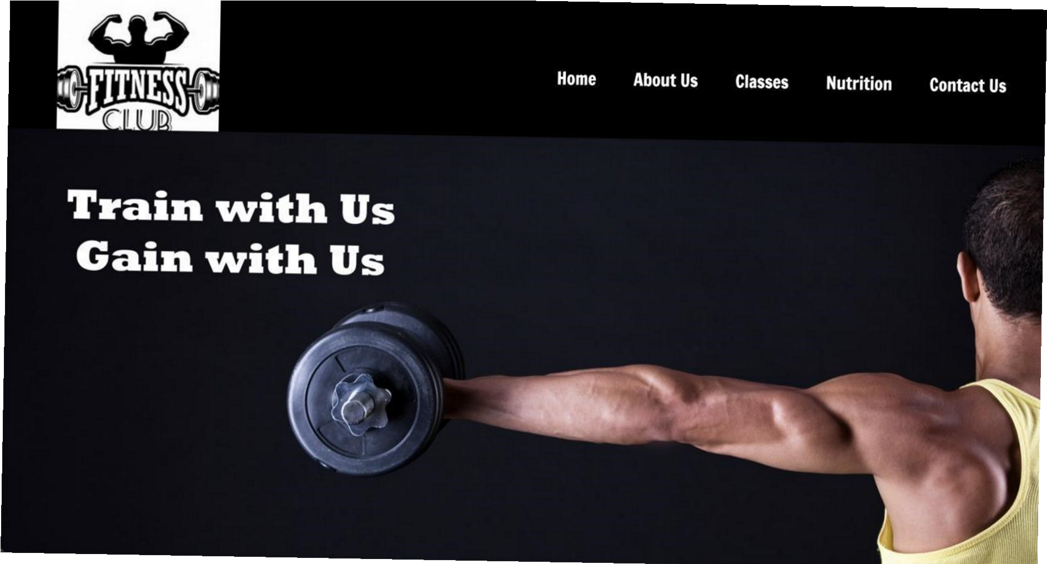

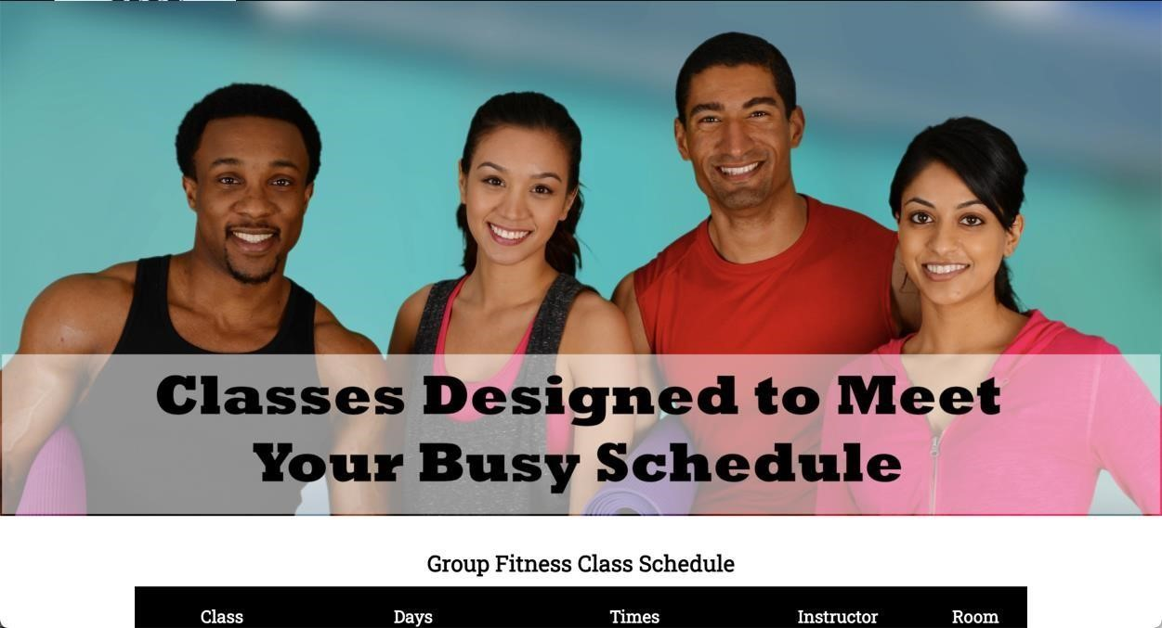

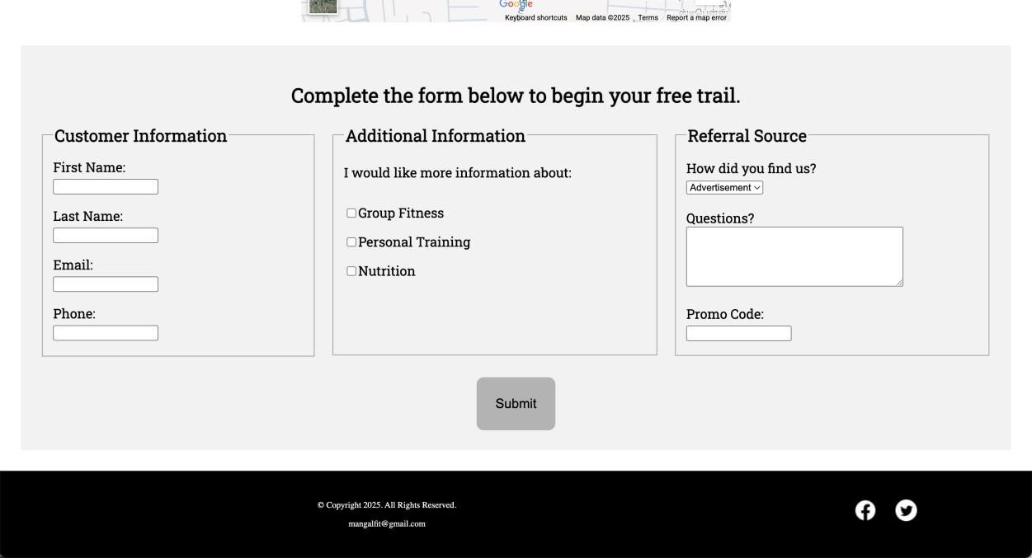

**GIT HUB LINK:**

https://github.com/Tamanna /gym-site